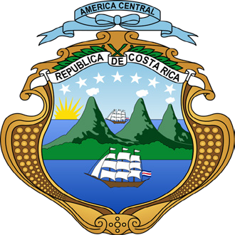
Consulate of Costa Rica in London
23 Woodstock Street, Mayfair, London W1C 2AS +44 (0) 20 7629 3111

Film & Media Permit Application

Company or individual applicant:
Full legal Company’s or Applicant name:

Address: City: Postal code: Telephone: Email:

- Team work:
Full Name: Full Name: Full Name: Full Name: Full Name: Full Name: Full Name: Full Name:

Position: Position: Position: Position: Position: Position: Position: Position:

Passport number: Passport number: Passport number: Passport number: Passport number: Passport number: Passport number: Passport number:

Production Type(s):
Film Documentary Publications Video clip Advertising Others
- Brief description of the project:

- When and where it would be broadcasted:
- Date of entering and leaving the country:
Time: Time:
From: To:

- Signature: 8. Date

Note:
*Attach a list of film equipment that will be used
*Copy of the passport of crew members

